14.1.5 Editors - Movie Clip Editor - Header - Tracking Mode - Clip Submode - Track Menu
Track Menu 1
Clear Solution 1
Clear Track Path 1
Lock 2
Unlock 2
Copy 2
Paste 2
Insert Keyframe 2
Delete Keyframe 2
Show/Hide 2
Show Hidden 2
Hide Selected 2
Hide Unselected 2
Last operator Hide Tracks 2
Unselected 2
Transform 3
Move 3
Last Operator Move Last 3
Move X Y Z 3
Axis Ortho 3
Orientation 3
Proportional editing 3
Proportional Falloff 3
Proportional Size 3
Connected 3
Projected(2D) 3
Resize 3
Last Operator Resize Last 4
Resize X Y Z 4
Orientation 4
Proportional editing 4
Proportional Falloff 4
Proportional Size 4
Connected 4
Projected(2D) 4
Reconstruction 4

Track Menu

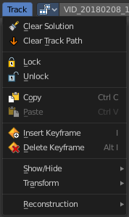
Clear Solution
Clears all calculated data.

Clear Track Path
Clears the currently active Track Path.

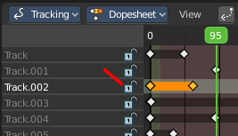
Lock
Locks the track in the dopesheet submode panel.

Unlock
Unlocks the track in the dopesheet submode panel.

Copy
Copy selected tracks to clipboard.

Paste
Pastes selected tracks from clipboard.

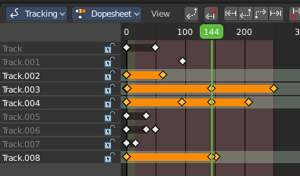
Insert Keyframe
Inserts a keyframe at current position in dopeshheet submode panel.

Delete Keyframe
Deletes keyframes at current position in dopesheet submode panel.

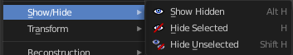
Show/Hide
Here you can show or hide tracks.

Show Hidden
Show all hidden tracks.

Hide Selected
Hide the selected tracks.

Hide Unselected
Hide the unselected tracks.

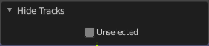
Last operator Hide Tracks

Unselected
Hide selected or unselected tracks.

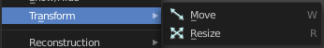
Transform
Track navigation.

Move
Move the selected track(s).

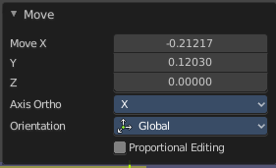
Last Operator Move Last

Move X Y Z
The transform values. Set x and y position of the track. Z value has no influence.

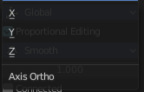
Axis Ortho
Defines the other axis of an imaginary shear axis plane.

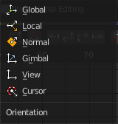
Orientation
Choose the orientation for the shear action.

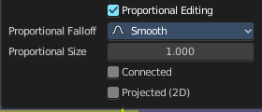
Proportional editing
Enables proportional editing. Activating proportional editing reveals further settings.

Proportional Falloff
Here you can adjust the falloff methods.

Proportional Size
Here you can see and adjust the falloff radius.

Connected
The proportional falloff gets calculated for connected parts only.

Projected(2D)
The proportional falloff gets calculated in the screen space. Depth doesn't play a role. When it's in the radius, then it gets calculated.

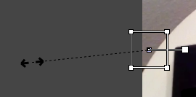
Resize
Resize the selected track(s).

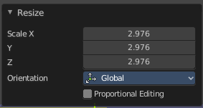
Last Operator Resize Last

Resize X Y Z
The transform values. Set x and y position of the track. Z value has no influence.

Orientation
Choose the orientation for the shear action.

Proportional editing
Enables proportional editing. Activating proportional editing reveals further settings.

Proportional Falloff
Here you can adjust the falloff methods.

Proportional Size
Here you can see and adjust the falloff radius.

Connected
The proportional falloff gets calculated for connected parts only.

Projected(2D)
The proportional falloff gets calculated in the screen space. Depth doesn't play a role. When it's in the radius, then it gets calculated.

Reconstruction
This menu once contained nothing but double menu entries that can be found in the panels. It is part of the Blender menu structure. And a addon may add an entry here. So it remains for compatibility reasons.

